**GLOBAL AIR TRANSPORTATION NETWORK**

**Introduction:**

Air transport network (ATN) is an example of transport networks and spatial networks. The nodes of the network are the airports and the links represent direct flight routes between two airports. Alternatively, cities can be considered as the nodes with links representing direct flight connection between them. Air transport networks can be defined worldwide as well as for one region or for one airline company; the scale of the network can be global or domestic.

**Overview:**

* The air transport system generally includes airports, ATC (air traffic control) system, and airlines. The airports represent the ground part of the system's infrastructure handling the aircraft operated by different airlines transporting passengers and freight/cargo shipments.
* The air transportation network is a complex network which has the properties of small-world networks and scale-free networks. The degree distribution of the nodes displays a heavy-tailed distribution. The hubs of the network have large connectivities and long-distance connectivities at the same time.

**Purpose:**

* Air Transport Network is one of a country's essential infrastructure assets. Air Transportation is a vital component for economic development and growth. Air Transportation provides the only global transportation network for people and goods.
* Air transportation allows people from different countries to cross international boundaries and travel other countries for personal, business, medical, and tourism purposes.

**Problem definition and Design thinking:**

**Empathy Map:**

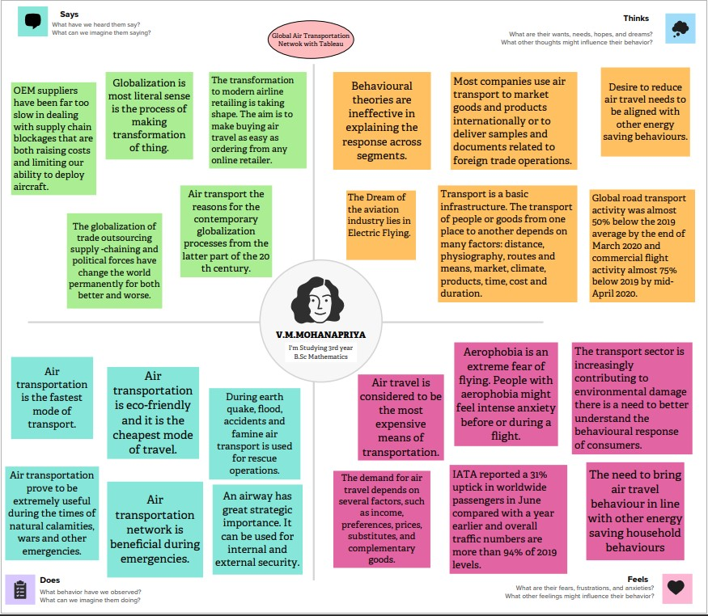

**Ideation and Brainstroming Map:**

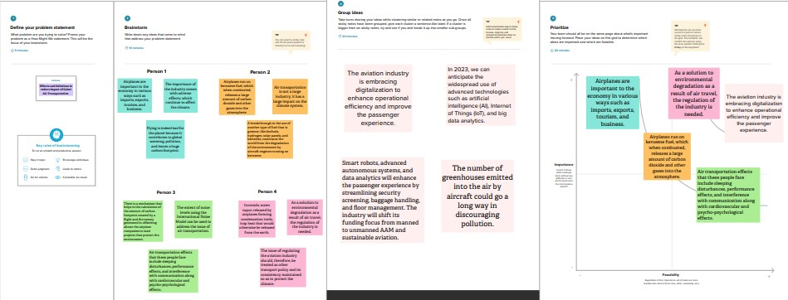

**Result:**

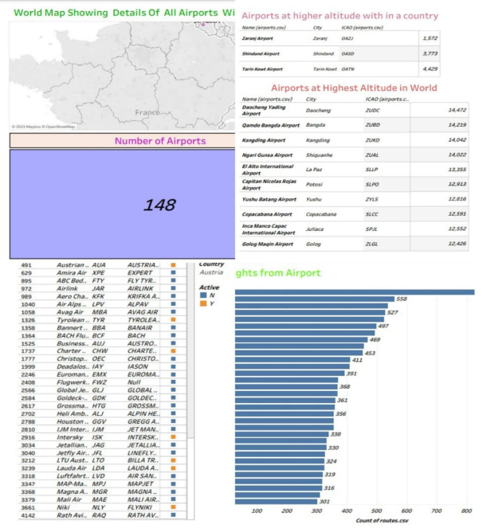 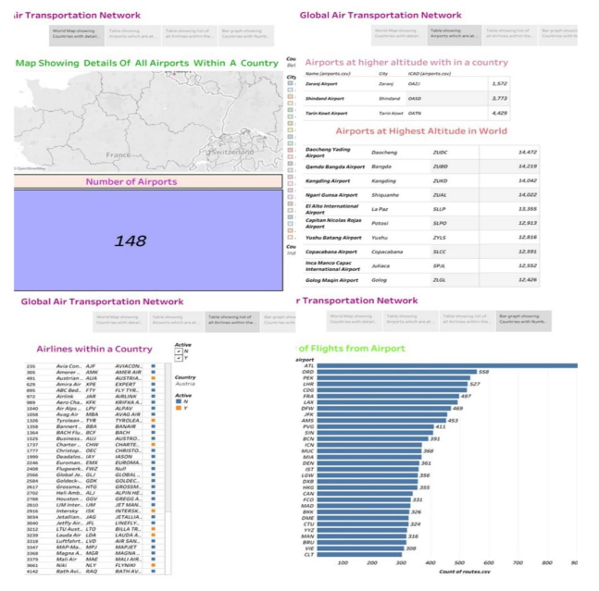

**Advantages and Disadvantages:**

**Advantages:**

* Air transportation is one of the fastest modes of travel. Aeroplanes can carry people, mail and lightweight goods to distant places in the shortest time possible.
* Airplanes can cover long distances in a matter of hours, enabling businesses to deliver goods quickly, especially for time-sensitive orders.
* Air transportation provides extensive global coverage, connecting businesses to various destinations around the world.
* Airlines maintain strict adherence to departure and arrival times, minimizing delays and enhancing supply chain efficiency.
* Airports have stringent security protocols in place to ensure the safety of cargo, including thorough screening processes and restricted access.

**Disadvantages:**

* Air transportation is best suited for high-value, time-sensitive goods that require swift delivery, rather than large-volume shipments.
* Air transportation has strict regulations regarding the transportation of hazardous goods.
* The speed, global reach, reliable timelines, reduced inventory holding costs, and enhanced security make air transportation an attractive option for many companies.
* Airplanes have limited cargo space compared to ships or trains.
* Businesses dealing with such goods need to comply with stringent regulations and find alternative transportation methods if necessary.

**Application:**

* The suitability of desktop workstations can be the key to staff productivity.
* Getting the specification right can be the difference between getting the job done and watching endless render bars.
* Some editing tools, for example, benefit from high-specification CPUs and more RAM.
* Monitor size, resolution, aspect ratio, brightness, contrast and colour performance determine suitability for editing, finishing, colour correction or other applications.
* Digistor can off flexible subscription licensing and render VFX plug-ins to cater for the production demands of any facility.
* Underpinning a smooth workflow are network, storage, backup, archiving and disaster recovery systems.
* All content creators need to quickly and efficiently ingest, store, access and share increasingly larger files in a growing variety of formats and resolutions.

**Conclusion:**

* Air transportation is less than a century old, but is now a major contributor to globalization and is continually reshaping itself to meet the demands of the economic and social integration that globalization engenders.
* Economically, in static terms, globalization occurs to facilitate the greater division of labor and allows countries to exploit their comparative advantage more completely.
* Air transportation has played a role in the past, and it seems inevitable that it this role will continue in the future.

**Future Scope:**

* The most recent estimates suggest that demand for air transport will increase by an average of 4.3% per annum over the next 20 years. If this growth path is achieved by 2036 the air transport industry will then contribute 15.5 million in direct jobs and $1.5 trillion of GDP to the world economy.
* Emerging technologies are reshaping with robotics, artificial intelligence, the internet of things, unmanned aircraft systems and the push for hybrid and electric airplanes – just to name a few. Alternative fuels can significantly change the current scenario of aviation in support of the environmental protection.
* The Aviation Market size is expected to grow from USD 333.96 billion in 2023 to USD 386.21 billion by 2028, at a CAGR of 2.95% during the forecast period. The COVID-19 pandemic affected the aviation market in many ways, and the effect of the pandemic is expected to continue even during the forecast period.
* The global airline industry market is projected to grow at a CAGR value of 25.5% from 2022 to 2027. The worldwide airline sector is expected to grow in the next few years, owing to rising disposable income, rapidly growing middle class, and increased travel demand.